Darius Quick
2/13/24
Runtime Analysis
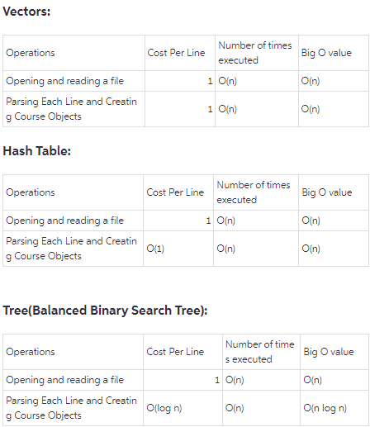
The Abstract Data Types Vectors, Hash Tables, and Binary Trees each have different Big O factors, advantages, and disadvantages for use. These differences define when one Abstract Data Type should be used over another or for specific purposes. I will be explaining the differences of each Abstract Data Type’s runtime/memory data structure, advantages, and disadvantages.
When opening and reading a file the cost per line of using a hash table is 1. The number of times executed is O(n) and the Big O value is also O(n). When parsing each line of the file and creating course objects the cost per line is O(1). The number of times executed is O(n) and the Big O value is also O(n). The two advantages of using a hash table for the assignment are that they have fast look up time and that they are suitable for quick retrieval of the information that is stored in them. The major disadvantage of using hash tables for the assignment is that, because it is complicated to implement, the memory storage has to be larger.
When opening and reading a file the cost per line of using a binary tree is 1. The number of times executed is O(n) and the Big O value is also O(n). When parsing each line and the course objects the cost per line is O(log n). The number of times executed is O(n) and the Big O value is O(n log n). One advantage of using a Binary Tree for the assignment is that they perform e very efficient when using deleting and inserting the information stored within it. Another advantage is that it is extremely useful for sorting information. The unfortunate disadvantage is that it has a higher use of memory due to the structure of the abstract data type.
When opening and reading a file the cost per line of using a vector is 1. The number of times executed is O(n) and the Big O value is also O(n). When parsing each line of the file and creating the course objects the cost per line is still 1. The number of times executed is O(n) and the Big O value is also O(n). There are two main advantages if I were to use Vectors for this assignment. Vectors operate with a higher level of quality in sequential access of data elements. Vectors also have large memory storage. One major disadvantage of using a Vector for this assignment are that it can be expensive to use insertions or deletions of the information in the vector in the middle of the assignment. Another disadvantage is that, when compared to hash tables or binary trees, it is slower to search for information within the vector.
For the assignment I would recommend for a hash table to be used because of the extremely fast lookup times using the cost per line Big O factor O(1) for retrieving the data. This will provide quick access to course data. Especially because each course can have it own unique identifier. Hash tables are really good at using this feature.

